# Hardware component

**1. nRF24L01 Module**

-Power consumption is around 12 mA during transmission which is even lesser then the led.

-It can operate with baud rates from 250 Kbps up to 2 Mbps

-Its range can reach up to 100 meters if used in open space and with antenna..

- Its can both send and receive the data simultaneously.

- Each module can communicate with up to 6 other modules.

- It uses the 2.4 GHz band.

- It can send 1->25 bytes of raw data at the transmission rate of 1 MB

- It has 125 different channels.

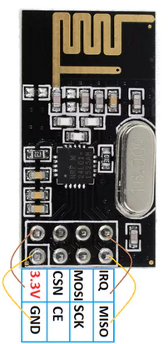

Software:

Useful library for RF module at link: [**http://tmrh20.github.io/RF24/**](http://tmrh20.github.io/RF24/)

Go into Library Manager -> Search RF24L -> Install

2. **JoyStick**

The analog joystick is similar to two potentiometer connected together, one for the vertical movement (Y-axis) and other for the horizontal movement (X-axis). The joystick also comes with a Select switch

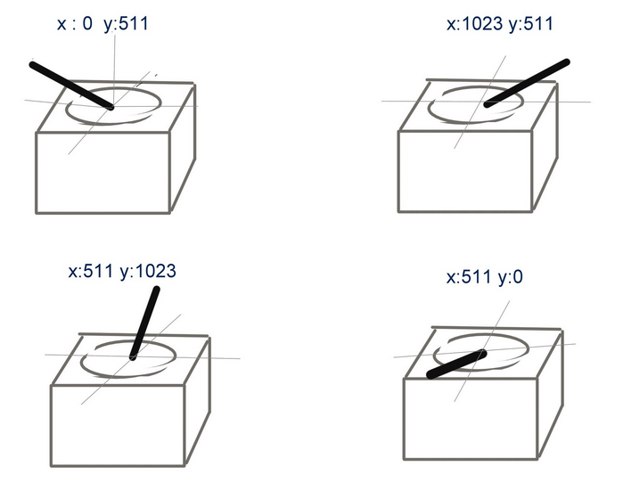

Software: read analog signal.

**3. L298 HBridge Circuit**.

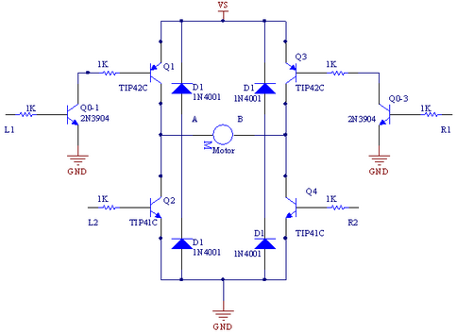

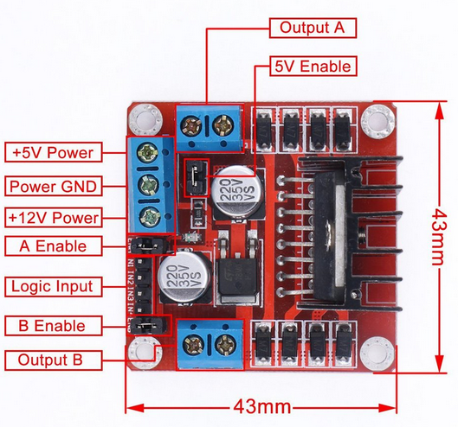

**4. Arduino Uno**

Arduino Uno is base on AVR microcontroller called Atmega328. This controller comes with 2KB SRAM, 32 KB of flash memory, 1 KB of EEPROM. Arduino Board comes with 14 digital pins and 6 analog pins. On-Chip ADC is used to sample these pins. A 16 MHz frequency crystal oscillator is equipped on the board.

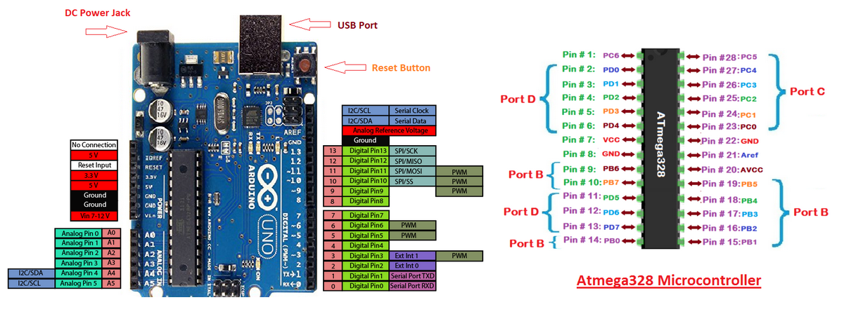

# Software Architecture

